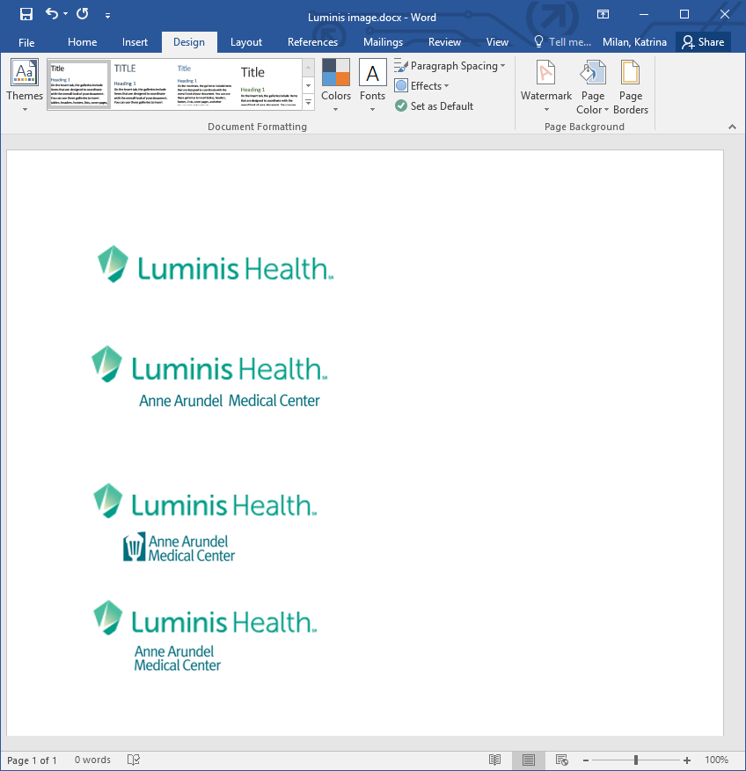  ANTI COAGULATION SERVICES  Initial Clinical Referral Contract - Community  Email: ACS@luminishealth.org P: 443.481.5826 / F: 443.481.5798 | ***For ACS Office Use Only***  Patient Label ID

Patient’s Name: Birthdate:
Patient Demographics Required: Phone: Home: Work:
Birthdate Cell: Other:
INCLUDE REQUIRED DOCUMENTATION FOR ALL REFERRALS:
UPDATE & COMPLETE: MEDICATION LIST PROBLEM LIST

Reason for Referral:
x Z51.81 Therapeutic Drug Level Monitoring | x Z79.01 Long term (current) use of anticoagulants
Patient’s Indication for therapy: (Choose every diagnosis that applies or provide ICD-10 code and description):
Atrial Fibrillation  I48.0 Paroxysmal I48.11 Longstanding Persistent A-Fib  I48.20 Chronic I48.19 Other Persistent A-Fib I48.21 Permanent I48.91 Other/Unspecified | Deep Vein Thrombosis (DVT)  I82.409 Acute Z86.718 History of DVT  I82.509 Chronic Z86.718 History of Recurrent DVT
Atrial Flutter  I48.3 Typical I48.4 Atypical I48.92 Other/Unspec. | Pulmonary Embolism (PE)  I26.99 Acute I27.82 Chronic Z86.711 History of PE
I42.9 Cardiomyopathy | D68.59 Hypercoagulable state
Z86.73 History of Stroke/TIA | D68.51 Factor V Leiden
Z95.2 Mechanical Heart Valve Aortic Mitral | D68.61 Antiphospholipid Syndrome
Other: ICD-10 Diagnosis Code: Description:

Anticoagulation Medication:
Medication: Coumadin/Warfarin (see required information below) Eliquis Pradaxa Xarelto Savaysa
Transition from _______________ to ________________

Onset of Therapy (Date): Initial Dosing:
Duration of Therapy: (Choose ONLY ONE)
Indefinitely Other (Therapy End DATE must be specified): _________________ (MM/DD/YYYY)

For Coumadin/Warfarin patients:
Target INR Range: 1.6-2.2 1.8-2.5 2.0-3.0 2.5-3.5 Other:
Lovenox Bridging: (AAMC ACS will default to Chest guidelines and/or discuss with ACS Medical Director if no option is checked)
Bridging if off warfarin for procedures? Yes No Other:
Last INR Result: Date: | D/C Lovenox when INR is greater than

Initial Appointment:
Immediately 1 Week 2 Week 3 Week 4 Week Other:

Community Physician Signature:____________________________________Date:_______________Time:____________
Community Physician Name (Print):_________________________________Phone: ______________Fax:_____________
*Responsible Referring Physician (Community Physician): The clinic will test, dose, and prescribe as the acting agent as allowed for the referring physician who still remains ultimately responsible for the patient’s anticoagulation therapy. The patient will be referred back to this physician if there are any issues with compliance or referrals.
x ACS Clinic Staff may renew Anticoagulation Therapy prescription to patient’s pharmacy as per ACS Pharmacy policy.

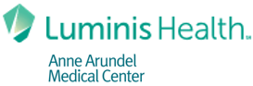  ANTI COAGULATION SERVICES  Initial Clinical Referral Contract - Community  P: 443.481.5826 / F: 443.481.5798 | Patient Label ID

This referral is required for clinical purposes.
This is not a referral for insurance purposes.
The referral is a legal contract between the provider and pharmacist allowing Anti Coagulation Services (ACS) to become the acting agent for the referring physician.

Clinic staff will contact patients for scheduling upon receipt of the referral.
All patients are scheduled. This is not a walk in clinic.

The initial new patient appointment is scheduled for 45 minutes to review patient’s medical history and new patient education regarding the medication. New patients are scheduled for their first 5-6 appointments in an effort to get them to a therapeutic level as quickly as possible (Two times/week for two weeks, then once/week thereafter). Appointments are scheduled for further future appointments upon check out as directed by the protocol.

The AAMC hospitalist may initiate the referral to the clinic. The initial referral is only valid for up to 30 days. A community physician must countersign the referral to assume the role of responsible referring physician. The AAMC hospitalist should confirm with the community physician that they will assume responsibility and choose to refer the patient into the clinic.

ACS is obligated to follow the hospital approved protocol as the acting agent for the physician. Any deviation from approved protocol requires the referring physician’s direction and authorization.

Hospital protocol requires that both a current medication and problem list be submitted with the completed clinical new patient referral. AAMC hospitalists may update both lists in Epic. The patient should not be scheduled without both lists.

